**Online Diary – Employability Game**

Groups Members – Connor Winspur, Sean Colbourne, Connor Hadley, Alyssa/Daniel Lamb

**Overview**

The task that was set was to design a game around the theme of employability. Our group decided to design a board game that had two teams of two facing each other in order to acquire attributes that their employer would be looking for, with the highest score winning at the end.

**Mechanics**

1. Points system: Gain more points than the other candidates by boosting your CV with cards.
2. Trading: Allowing teams to trade different attribute cards as well as forcing other teams to discard theirs.
3. Bluffing: Using a combination of wit and vocal skills to convince other players you're in a better or worse position than you actually are. Also tying this into trading, allowing you to complete sets of cards easier.
4. Cards: Can be employer specific allowing extra points, attributes and abilities to be handed out to players upon completing different sets.

**Rules**

* The player must complete their CV by collaborating with their team mate to collect the most points.
* The players must split themselves into teams of 2 before selecting an employer card which lays out the requirements for you to win the game.
* Each player from every team must then draw 5 attribute cards to start their hands off.
* Each player from every team then rolls a die and combines the totals to decide which team goes first, then decides between themselves which individual player will play first.
* Each turn a player will draw two cards to add to their hand. Whilst a maximum of 2 cards can be played each turn (however you can choose to play 1 or 0 cards if you wish) During your turn you may choose to trade with the opposing team however this counts as playing a card.
* Alternating turns between each player and team the game is completed when one team has the required amount of points listed on their specific card that allows them to be hired for the job.

**Assets**

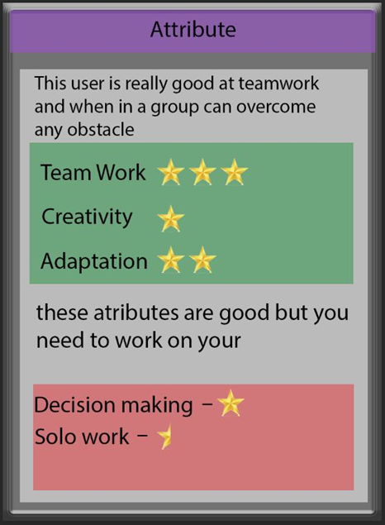

[D]

[C]

[B]

[A]

**Figure 1. Attribute Card.** The scene shows the card title [A], a description of the card [B] and the positive [C] and negative [D] points the player gains from the card.

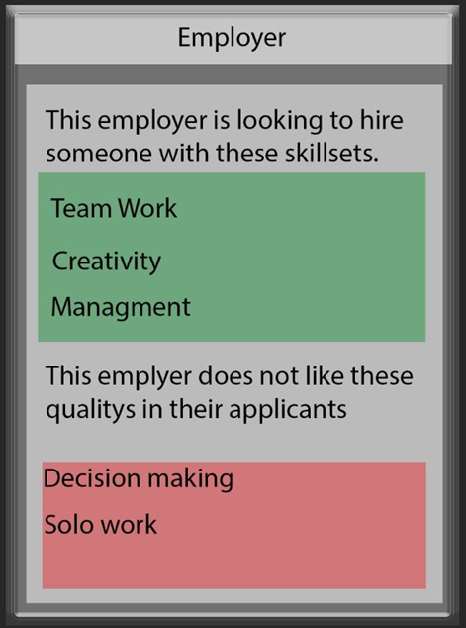





**Figure 2. Employer Card.** The scene shows the name of the employer [A], the skills the employer is looking for on the players cards [B] and the skills they are not looking for [C].

**Experience and Skills Learnt**

During this session there were many problems that arose while working in a team, this mainly occurred due to lack of both experience and communication. While the group managed to choose a theme and design for the game quickly, they struggled on refining the details and finding the resources to create the assets for the game. Teamwork was essential during this project as completing it either alone or while not working effectively together would have prevented any progress being made. There were many other employability skills in use other than teamwork, such as project management, communication, time management, critical thinking, decision making and many more. In order to improve on this work further skills in time management, communication and decision making needs to be developed, as together they will ensure the work is done within the specified amount of time.